**SRM INSTITUTE OF SCIENCE AND TECHNOLOGY TIRUCHIRAPPALLI**

**DEPARTMENT OF MATHEMATICS**

**Academic year 2024-25**

**Assignment – 5**

**21MAB302T – Discrete Mathematics**

**Class: III – ECE**

Instruction: Execute the Problem 1 and 2 in your MATLAB login and take the output with your login details. Submit it on or before **16.10.24** as Soft copy(Screen shot with your login name) as well as hard copy.

**Example:**

Find the transitive closure for the given relation and hence find the corresponding Graph. Relation = R= {(1,1),(1,3),(1,4),(2,2),(3,4),(4,1)} by using MATLAB Code

Solution & Output:

s = [1 1 1 2 3 4 ];

t = [1 3 4 2 4 1];

G = digraph(s,t);

plot(G,'Layout','subspace')

H=transclosure(G);

plot(H);

A=adjacency(G)

B=adjacency(H)

D=digraph(B(1:4,1:4));

B = 4x4 sparse double matrix (9 nonzeros)

(1,1) 1

**Transitive closure of the graph G**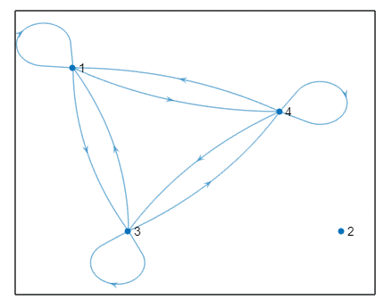

(3,1) 1

(4,1) 1

(1,3) 1

(3,3) 1

(4,3) 1

(1,4) 1

(3,4) 1

(4,4) 1

**Problem: 1**

**Find the transitive closure for the relation R={(1,2),(1,5),(2,2),(3,3),(3,4),(4,4),(5,1)} and hence find the corresponding graph by using MATLAB code.**

**Problem : 2**

**Find the transitive closure for the relation R={(1,4),(2,1),(2,2),(2,3),(3,2),(4,3),(4,5),(5,1)} and hence find the corresponding graph by using MATLAB code.**